Table of Contents
Table of Contents i
Revision History ii
Abstract iii
1. Introduction 1
1.1 Product 1
1.2 Background 1
1.3 Objective(s)/Aim(s)/Target(s) 1
1.4 Scope 2
1.5 Business Goals 2
1.6 Document Conventions 3
1.7 Miscellaneous 4
2. Overall Description 5
2.1 Product Features 5
2.2 Functional Description 6
2.3 User Classes and Characteristics 6
2.4 Design and Implementation Constraints 7
2.5 Assumptions and Dependencies 8
3. Technical Architecture 10
3.1 Application and Data Architecture 13
3.2 Component Interactions and Collaborations 15
3.3 Design Reuse and Design Patterns 21
3.4 Technology Architecture 21
4. Screenshots/Prototype 22
4.1 Workflow 22
4.2 Screens 23
4.3 Additional Information 28
5. Other Design Details 28
6. Revised Project Plan 29
7. References 29
Appendix A: Glossary 31
Appendix B: IV & V Report 31

Revision History
Name | Date | Reason For Changes | Version

Abstract
The diagrams are interactive, allowing users to customize nodes and connections, and the app is fully mobile-responsive, ensuring a smooth experience on any device. The project avoids complex AI features and focuses on offering a lightweight, user-friendly tool for basic diagram creation. Creating system diagrams like flowcharts, use case diagrams, sequence diagrams, and DFDs is time-consuming and often requires manual input, making the process prone to errors. Many tools in the market are overly complex, requiring deep knowledge of diagram structures and often being too slow or cumbersome to use for simple projects. Additionally, the lack of mobile-friendly tools makes it harder for users to work on diagrams across multiple devices.

Introduction

Product
The FlowMind AI Diagram Generator is a web and mobile application designed to simplify and automate the creation of system modeling diagrams such as flowcharts, use case diagrams, sequence diagrams, and DFDs. It addresses the inefficiency and errors in manual diagram creation by providing an intuitive, lightweight, and mobile-responsive platform. The end product is a practical tool that enhances productivity and usability, making it suitable for individuals, small teams, and startups requiring efficient and accessible diagramming solutions.

Background
System modeling is essential for visualizing processes and interactions in software development, system engineering, and project management. Existing tools like Lucidchart, Draw.io, and Microsoft Visio dominate the market but often cater to advanced users, requiring significant manual input and steep learning curves. These tools are also less optimized for mobile responsiveness, limiting their usability in modern, fast-paced environments.
FlowMind AI differentiates itself by focusing on simplicity and accessibility. Unlike existing solutions, FlowMind automates diagram generation using structured inputs, removing the need for extensive technical expertise. Its lightweight design ensures seamless functionality across devices, including smartphones and tablets. Additionally, while tools like Lucidchart and Visio require subscriptions or licenses, FlowMind offers a cost-effective alternative tailored to the needs of small teams and startups. By addressing these gaps, FlowMind positions itself as a unique and efficient solution in the domain of diagramming tools.

Objective(s)/Aim(s)/Target(s)
The primary objectives of the FlowMind AI Diagram Generator project are:

Automate Diagram Creation: Provide a platform for generating flowcharts, use case diagrams, sequence diagrams, and DFDs automatically using structured user inputs.

Enhance Accessibility: Develop a mobile-responsive application to ensure seamless usability across desktops, tablets, and smartphones.

Simplify User Interaction: Design an intuitive interface that minimizes the learning curve, making it accessible to non-technical users.

Support Customization: Enable users to edit generated diagrams by modifying nodes, labels, shapes, and connections.

Facilitate Exporting: Implement functionality to export diagrams in high-quality PNG and PDF formats for reports and presentations.

Improve Efficiency: Reduce the time and effort required for manual diagram creation, focusing on lightweight functionality and speed.

Fill Market Gaps: Address the lack of simple, mobile-friendly, and cost-effective diagramming tools available for small teams and startups.

These objectives ensure the project delivers a practical, user-friendly, and efficient solution, contributing significantly to the field of system modeling and diagramming tools.

Scope
The scope of the FlowMind AI Diagram Generator includes the following:

Diagram Types: Automated generation of flowcharts, use case diagrams, sequence diagrams, and data flow diagrams (DFDs).

Customization Features: Allow users to modify nodes, labels, shapes, and connections within generated diagrams to meet specific needs.

Cross-Platform Compatibility: Ensure functionality across desktops, smartphones, and tablets with responsive design.

Export Options: Provide the ability to export diagrams in multiple formats, such as PNG and PDF, for integration into documents and presentations.

Ease of Use: Focus on a user-friendly interface accessible to individuals with minimal technical expertise.

Lightweight Functionality: Optimize for speed and efficiency to support quick diagram creation without requiring extensive computational resources.

Market Focus: Target small teams, startups, and individual users who need an accessible and efficient tool for creating system diagrams.

The project does not include advanced AI-driven analysis, real-time collaboration features, or integration with enterprise-grade tools in its initial scope. However, these features may be considered for future expansions.

Business Goals
The FlowMind AI Diagram Generator is designed to address the following business goals:

Streamline Diagram Creation: Reduce the time and effort required for users to create system modeling diagrams.

Enhance Productivity: Provide a tool that improves efficiency, especially for small teams and startups working under tight deadlines.

Promote Accessibility: Deliver a mobile-responsive platform that allows users to work seamlessly across devices.

Reduce Costs: Offer a cost-effective alternative to expensive and complex diagramming tools available in the market.

Expand Market Reach: Cater to individuals, educational institutions, and small organizations that need simple and efficient diagramming solutions.

Encourage Adoption: Differentiate from competitors by offering a lightweight and user-friendly application focused on simplicity and usability.

Facilitate Integration: Enable users to integrate exported diagrams into their workflows, reports, and presentations with ease.

By achieving these goals, FlowMind aims to establish itself as a reliable and efficient tool in the diagramming software market.

Document Conventions
This SRS follows the following conventions and standards:

Font and Style:

Headings: Bold and numbered (e.g., 1. Introduction, 1.1 Product).

Body Text: Times New Roman, 12-point font.

Emphasized Terms: Key terms or concepts are italicized for clarity.

Document Structure:

Organized into sections and subsections, each clearly labeled with numbers and headings.

Lists are presented using bullet points or numbered lists for readability.

Special Notations:

Technical terms and external system names are written in bold.

Acronyms are defined when first introduced and included in a glossary.

Formatting:

Page margins set to 1 inch on all sides.

Text aligned to the left for consistency.

References:

References are cited using standard citation formats, and a dedicated section is included for sources.

These conventions ensure consistency, clarity, and professionalism throughout the document.

Miscellaneous
The FlowMind AI Diagram Generator project includes the following additional considerations to enhance project organization and execution:
Team Collaboration: Regular team meetings will ensure alignment on objectives, timelines, and deliverables.
Tool Usage: Project management tools like Trello or Asana will be used to track progress and manage tasks effectively.
Feedback Mechanism: A feedback loop involving beta testers and stakeholders will help refine the tool during development.
Documentation: Comprehensive documentation will be maintained to aid future maintenance and scalability.
Testing Environment: A staging environment will be set up for thorough testing before deployment.
These steps ensure a well-organized and efficient project workflow.

Overall Description

Product Features
The FlowMind AI Diagram Generator is a versatile tool designed to simplify diagram creation with features like automated generation of flowcharts, use case diagrams, sequence diagrams, and DFDs using structured inputs. It offers customization options for modifying labels, nodes, shapes, and connections, and includes predefined templates to streamline common use cases. The platform is mobile-responsive, ensuring usability across desktops, tablets, and smartphones, and supports cross-platform compatibility for various operating systems and browsers. With a user-friendly interface that minimizes the learning curve, it caters to both technical and non-technical users. Additionally, it provides export functionality, allowing diagrams to be saved as PNG or PDF files for easy integration into reports and presentations.
The FlowMind AI Diagram Generator includes the following high-level features:

- Automated Diagram Creation: Users can generate flowcharts, use case diagrams, sequence diagrams, and DFDs by providing structured inputs.
- Customization Options: Basic editing capabilities allow users to modify labels, nodes, shapes, and connections.
- Mobile-Responsive Design: The platform ensures usability across desktops, tablets, and smartphones.
- Predefined Templates: Templates simplify the diagram creation process for common use cases.
- Export Functionality: Diagrams can be exported in PNG and PDF formats for reports and presentations.
- User-Friendly Interface: The application is designed to minimize the learning curve, making it accessible to both technical and non-technical users.
- Cross-Platform Compatibility: Supports multiple operating systems and web browsers, ensuring flexibility for users.

Functional Description
The FlowMind AI Diagram Generator streamlines diagram creation with automated generation of flowcharts, use case diagrams, sequence diagrams, and DFDs based on structured user input. Users can manage inputs through forms, specifying entities, processes, or relationships to visualize. It offers customization tools for resizing nodes, updating labels, and repositioning connections, ensuring diagrams can be tailored to user needs. The platform supports exporting diagrams in PNG or PDF formats for seamless sharing and integration. With context-aware features, it adapts to user workflows by suggesting relevant diagram types based on input data. Additionally, its device compatibility ensures responsive and efficient performance on both mobile and desktop environments.

The FlowMind AI Diagram Generator provides the following core functionalities:

- Diagram Generation: Automates the creation of flowcharts, use case diagrams, sequence diagrams, and DFDs based on structured user input.

- Input Management: Users input data through forms, specifying entities, processes, or relationships to be visualized.

- Customization Tools: Basic tools enable modification of generated diagrams, including resizing nodes, updating labels, and repositioning connections.

- Export Options: Allows exporting diagrams in PNG or PDF format for easy sharing and integration.

- Context Awareness: The system adapts to the user’s workflow, providing relevant diagram types and suggestions based on input data.

- Device Compatibility: Ensures functionality across various devices, maintaining responsiveness and usability on mobile and desktop environments.

A high-level context diagram (if included) would illustrate the system’s interaction with users, data inputs, and outputs, showcasing the flow from data entry to final export.

User Classes and Characteristics
The FlowMind AI Diagram Generator caters to the following user classes:
- Casual Users:
Characteristics: Non-technical users with minimal diagramming experience.
Needs: Intuitive and easy-to-use interface for creating basic diagrams quickly.
Favored Class: High priority to ensure usability and simplicity.
- Small Teams/Startups:
Characteristics: Teams requiring diagrams for internal communication and documentation.
Needs: Quick creation, basic customization, and export options for reports.
Favored Class: High priority to support collaborative workflows.
- Educational Users:
Characteristics: Students and educators using diagrams for academic purposes.
Needs: Cost-effective, mobile-responsive tool with export functionality.
Importance: Secondary priority, overlapping needs with casual users.
- Advanced Users:
Characteristics: Users with technical expertise, such as developers and analysts.
Needs: Flexibility and advanced customization options.
Importance: Secondary priority, focusing on simplicity over advanced features.
The primary focus is on Casual Users and Small Teams/Startups to maximize usability and market reach.

Design and Implementation Constraints
The FlowMind AI Diagram Generator has the following constraints:

Technological Constraints:
The system relies on third-party libraries such as Mermaid.js and D3.js for rendering diagrams, which may limit advanced customizations.
Cross-platform compatibility requires adherence to web standards, restricting the use of platform-specific features.
Performance Constraints:
The application must be lightweight to ensure smooth performance on devices with limited processing power or memory.
Diagram generation and export processes must operate within 5 seconds to maintain user engagement.
Hardware Limitations:
Minimum hardware requirements include 2GB RAM and a 1.2 GHz processor to support basic functionality.
Security Considerations:
All user data transmitted over the network must be encrypted using SSL/TLS protocols.
If user accounts are implemented, strong password hashing (e.g., bcrypt) must be used to secure credentials.
Development Tools:
The system must be developed using HTML5, CSS3, and JavaScript, with React.js for the frontend and Node.js (if backend services are required).
Regulatory Policies:
If the application handles personal data, compliance with data protection regulations like GDPR and CCPA must be ensured.
Programming Standards:
Clean, modular, and well-documented code is required to facilitate future maintenance and scalability.
These constraints ensure that the development process adheres to performance, compatibility, and security standards, while aligning with the project’s objectives.

Assumptions and Dependencies
The FlowMind AI Diagram Generator relies on the following assumptions and dependencies:
- Third-Party Libraries:
  - The project assumes the continued availability and support of libraries like Mermaid.js, D3.js, and React.js for diagram rendering and frontend development.
  - Any major changes to these libraries could impact the timeline or functionality of the project.
- Internet Access:
  - The tool requires a stable internet connection for accessing the web-based platform and associated resources.
  - Limited connectivity could affect the user experience, particularly for exporting diagrams.
- Hardware and Software Requirements:
  - Assumes users will have devices with at least 2GB RAM, 1.2 GHz processors, and updated modern web browsers such as Chrome, Firefox, Safari, or Edge.
  - Older hardware or outdated browsers may not be fully supported.
- User Input Structure:
  - The system relies on users providing structured and accurate inputs for diagram generation.
  - Incorrect or incomplete input could result in errors or suboptimal outputs.
- Regulatory Compliance:
  - Assumes no additional regulatory or compliance requirements beyond those initially identified (e.g., GDPR, CCPA).
  - Any changes to legal requirements could necessitate updates to the system’s security and data handling practices.
- Development Environment:
  - Assumes the availability of development tools like Node.js, VS Code, and hosting platforms such as AWS or Azure.
  - Issues with these tools or platforms could delay development.
- Dependencies on Team Collaboration:
  - The project depends on effective communication and task management within the development team.
  - Delays or miscommunication could affect overall progress.
  - These assumptions and dependencies highlight potential risks that could impact the project if they are incorrect or change during development.

Technical Architecture
The technical architecture of software development lifecycle (SDLC) is where the blueprint for the system is created, translating requirements into a structured plan for development. This phase defines the system architecture, including components, modules, and their interactions, along with data flow and storage mechanisms. It involves selecting technologies, planning security measures, and creating detailed designs for features and functionalities. Key deliverables include system architecture diagrams, database designs, UI/UX prototypes, technical specifications, and integration plans. The design phase ensures the development team has a clear roadmap, reduces risks, and helps stakeholders visualize the system before implementation, laying the foundation for a scalable, secure, and efficient application.

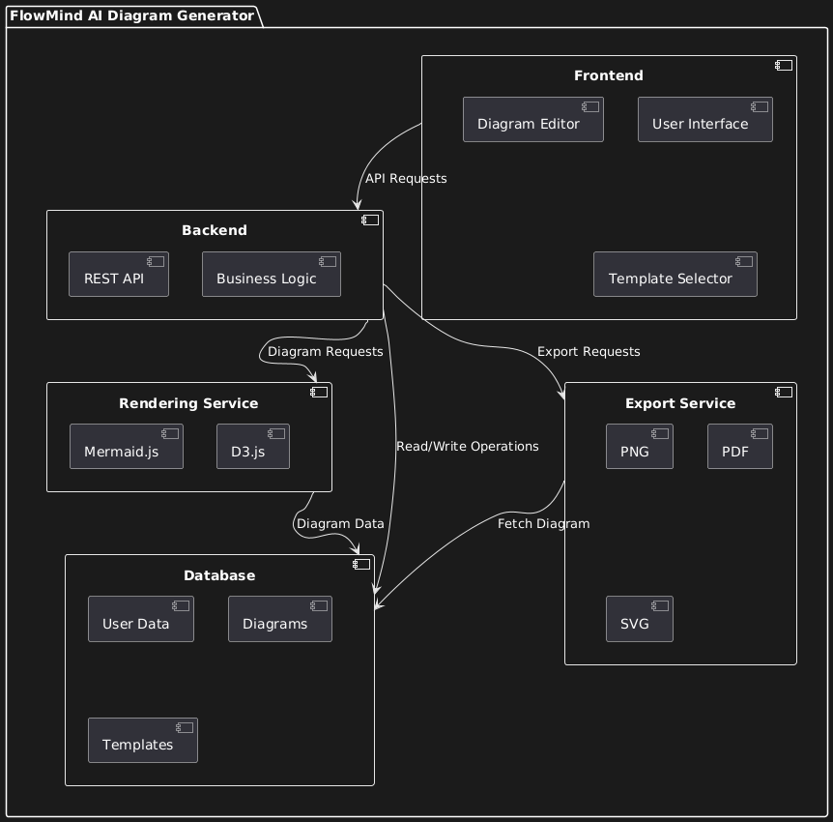

Figure 1: High Level Architecture Diagram 1

Application and Data Architecture
Component Diagram:

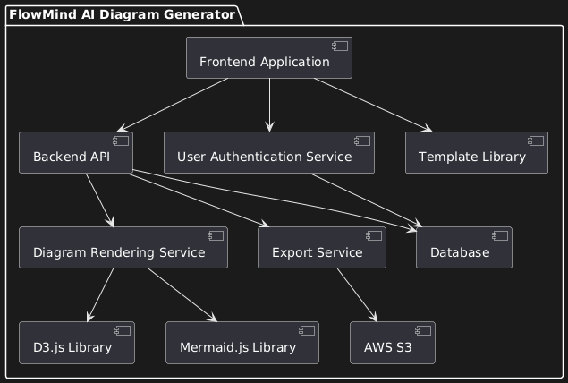
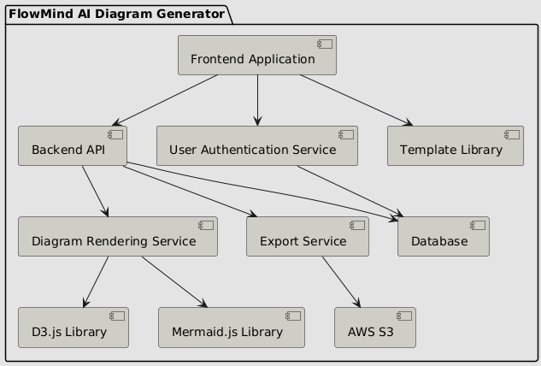
Figure 2: Component Diagram

ERD:

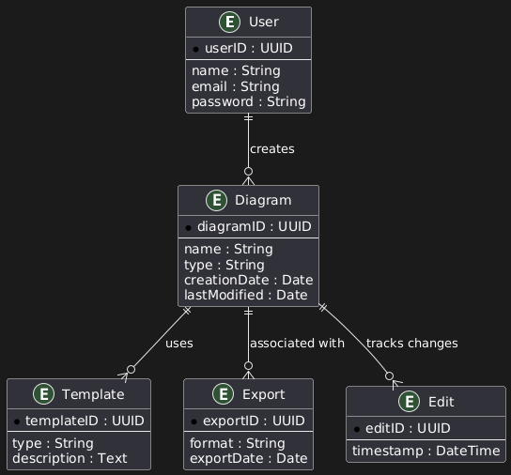
Figure 3: ER Diagram

Class Diagram:

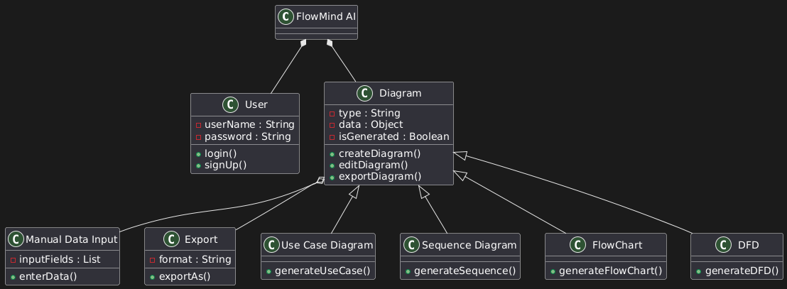

Figure 4: Class Diagram

Activity Diagram:

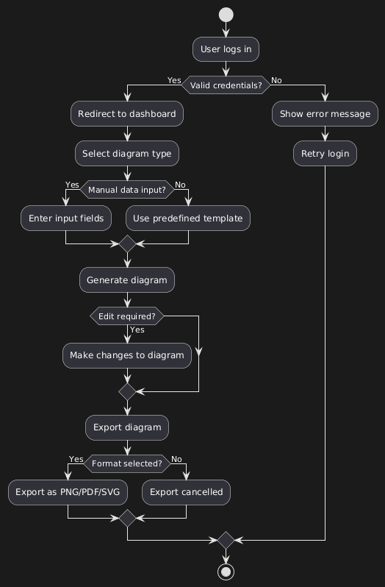
Figure 5: Activity Diagram

Decision Table:

Condition | C1: Valid Login? | C2: Diagram Type Selected? | C3: Manual Data Input? | C4: Edit Required? | C5: Export Format Selected?
Rule 1 | Yes | Yes | Yes | No | Yes
Rule 2 | Yes | Yes | No | Yes | Yes
Rule 3 | Yes | No | - | - | -
Rule 4 | No | - | - | - | -
Rule 5 | Yes | Yes | Yes | Yes | No

Component Interactions and Collaborations
The FlowMind AI Diagram Generator consists of multiple components working collaboratively to achieve the system's objectives. Below is an overview of the interactions between these components, accompanied by appropriate diagrams.

Interactions Overview:

User Interaction:
Users interact with the Presentation Layer via web or mobile browsers. Data entered by the user is sent to the Application Layer through RESTful APIs.
Application Layer Processing:
The Application Layer processes inputs, validates them, and interacts with the Data Layer for storage or retrieval.
It also generates diagrams using predefined templates and customization logic.
Data Layer Management:
MongoDB is used to store and retrieve user projects, templates, and configurations.
Queries from the Application Layer are executed to maintain data consistency.
External Services and Integrations:
The system leverages services like AWS S3 for exporting diagrams and cloud storage.
Amazon Kinesis is used for event streaming and real-time updates.
Collaboration and Updates:
Changes made by users are communicated across layers, ensuring synchronized updates and efficient workflows.
Sequence Diagram:

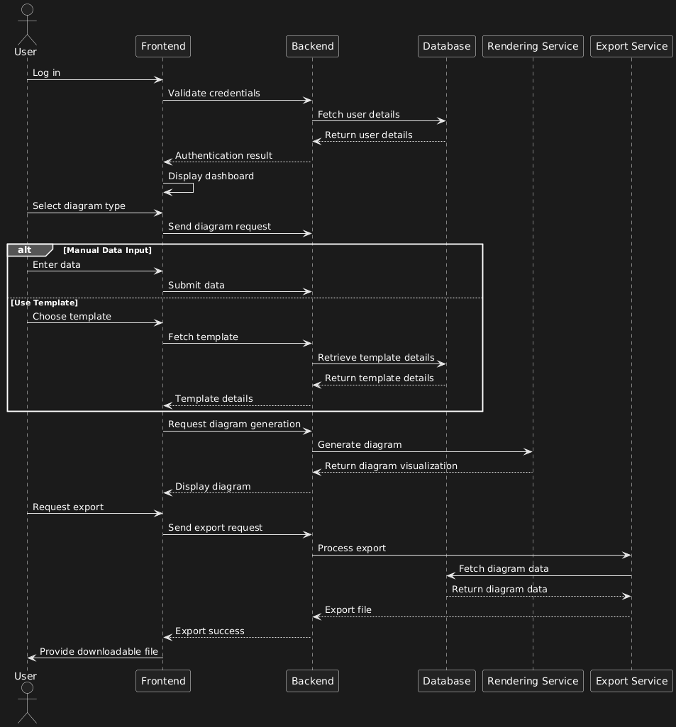

Figure 6: Sequence Diagram

Collaboration Diagram:

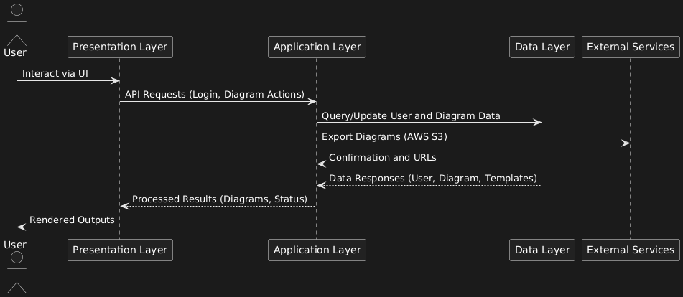

Figure 7: Collaboration Diagram

Event Traces Diagram:

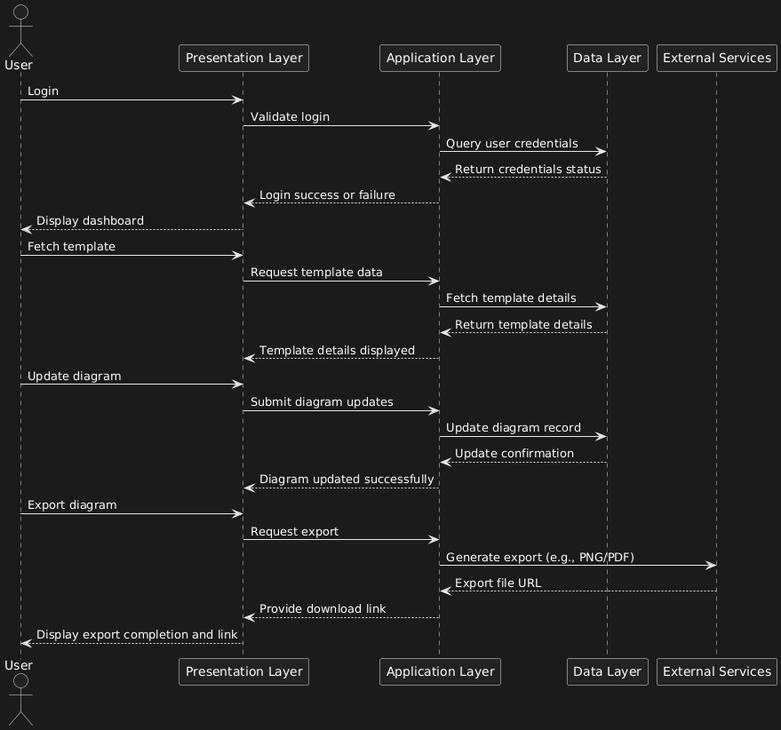

Figure 8: Event Traces Diagram

Data Flow Diagram:

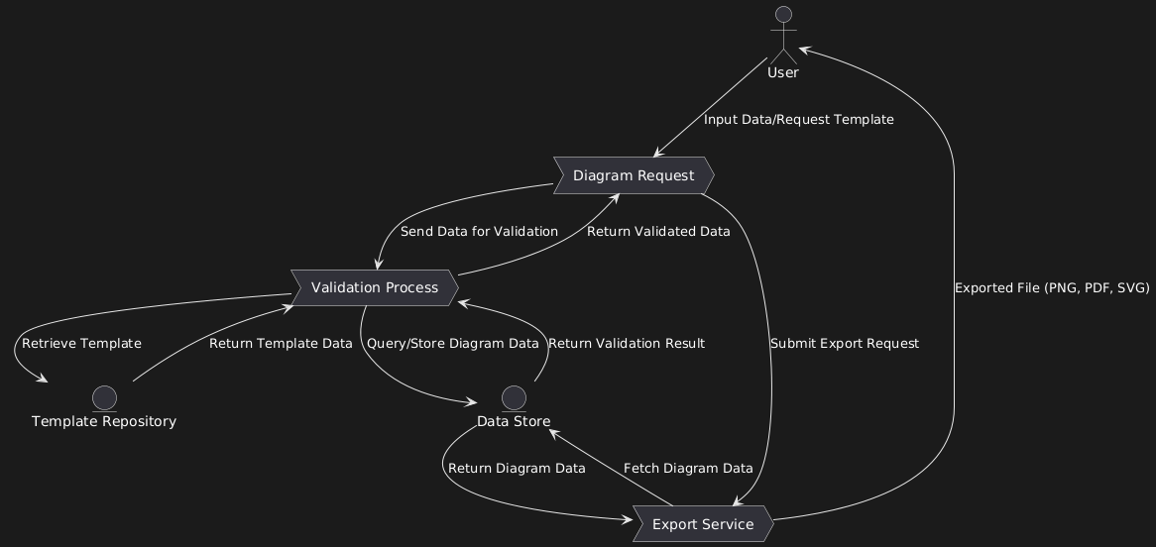

Figure 9: Use Case Diagram

Activity Diagram:

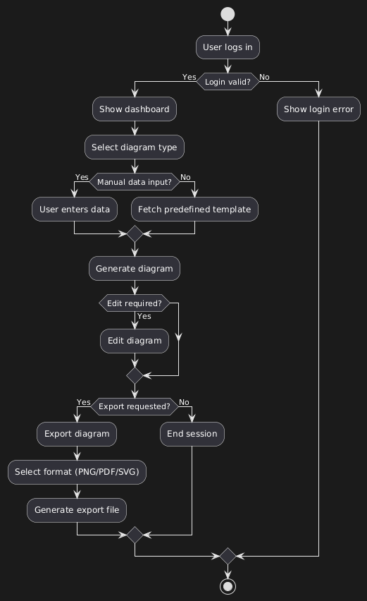

Figure 10: Activity Diagram

Design Reuse and Design Patterns
Design Reuse

Reusable Components: Template repository, export module, and authentication system reused across multiple features.
Reusable Libraries: Diagram rendering (Mermaid.js, D3.js), export functionality (jsPDF), and backend utilities (Node.js APIs).
Design Patterns
MVC: Separates presentation, logic, and data layers (React.js frontend, Node.js backend, MongoDB).
Factory Pattern: Dynamically generates diagram objects (e.g., flowcharts, sequence diagrams).
Observer Pattern: Syncs frontend with backend updates in real time.
Template Method Pattern: Base logic for diagram rendering, customized per diagram type.

Technology Architecture
Platform
Frontend: React.js for a responsive interface.
Backend: Node.js for business logic and API handling.
Database: MongoDB for storing user data, diagrams, and templates.
System Hosting
Cloud Hosting: AWS or Azure for scalability and reliability.
Connectivity Requirements
Internet access with HTTPS for secure data transmission.
Modes of Operation
Online Mode: Full functionality with cloud connectivity.
Offline Mode (Future Scope): Limited local functionality.
Additional Components
AWS S3: Storing exported diagrams.
CDN: Faster delivery of templates and static assets.

Screenshots/Prototype
4.1 Workflow

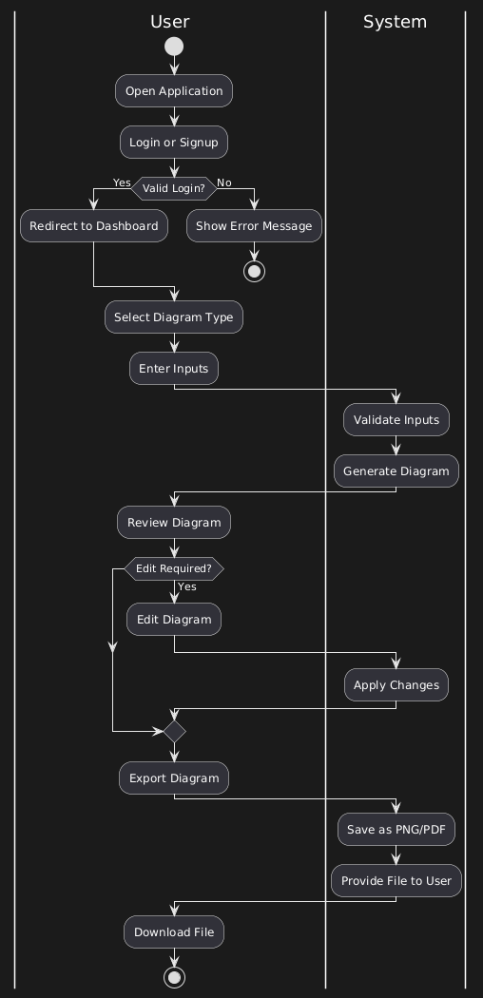
Figure 10: Swimlane Diagram

Screens
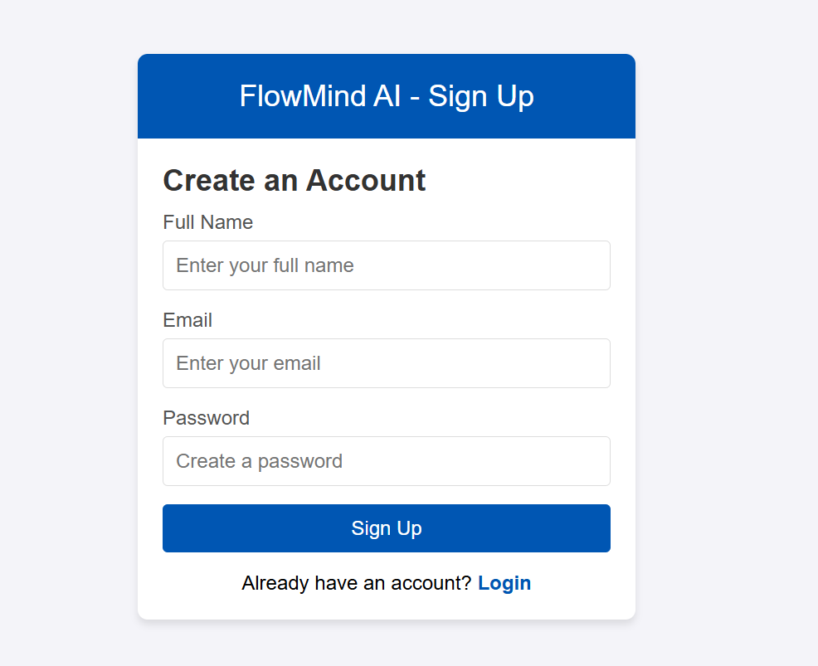

Screen 1: SignUp Page

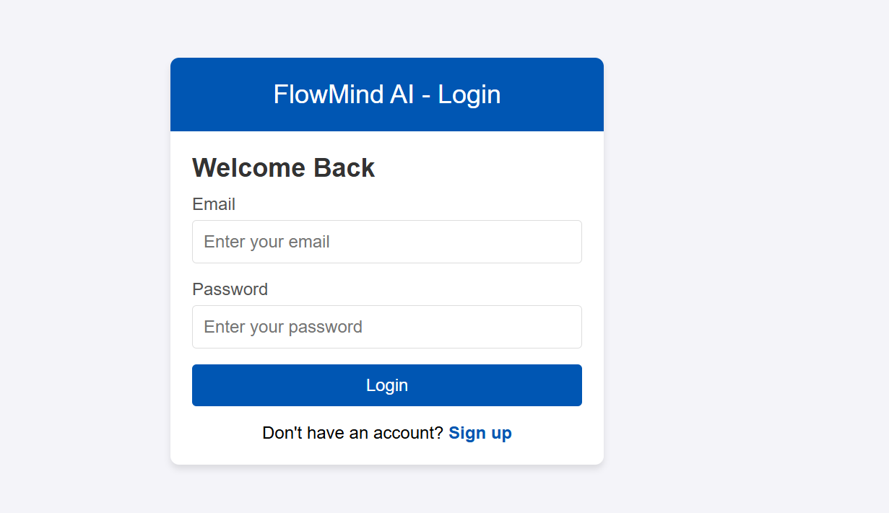
Screen 2: LogIn Page

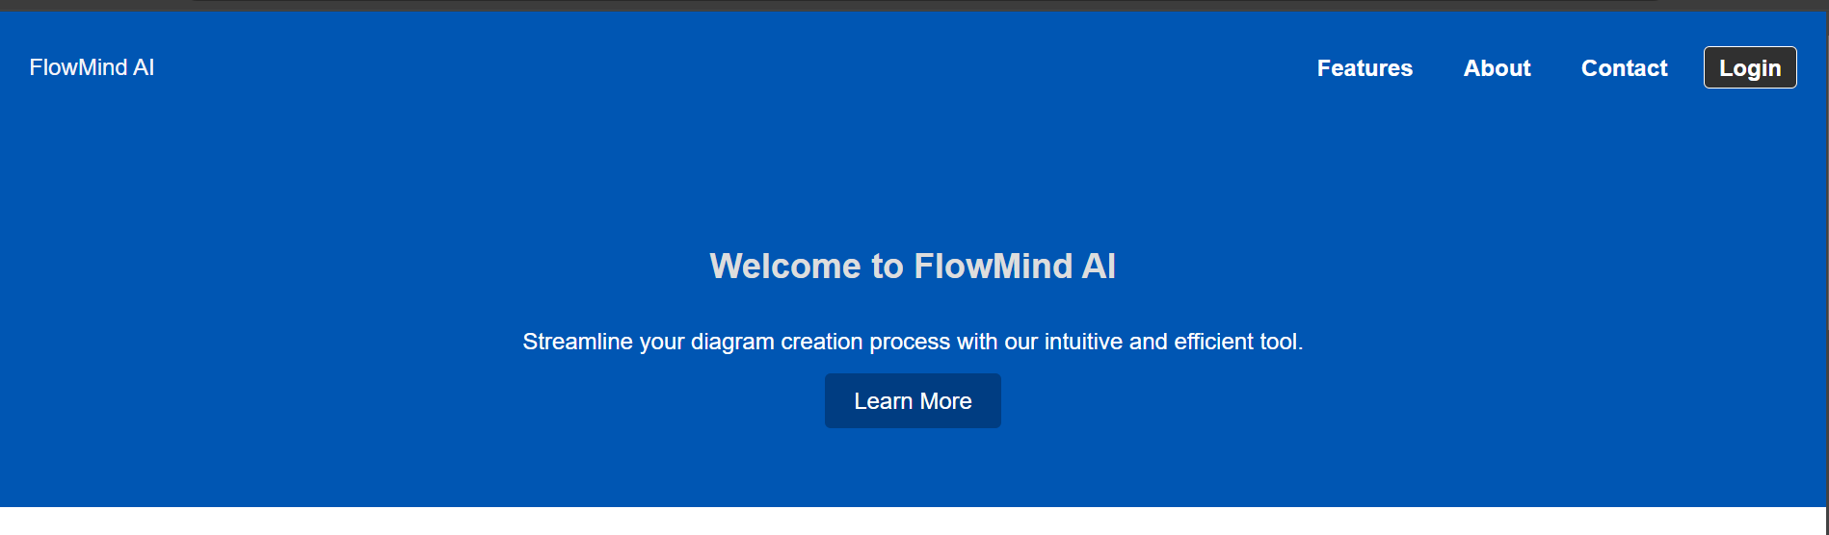
Screen 3: Home Page

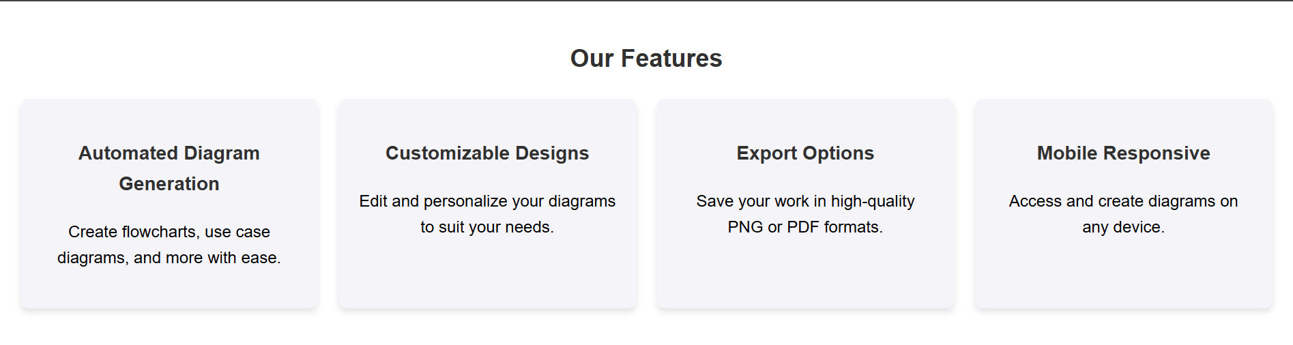
Screen 3.1: Features

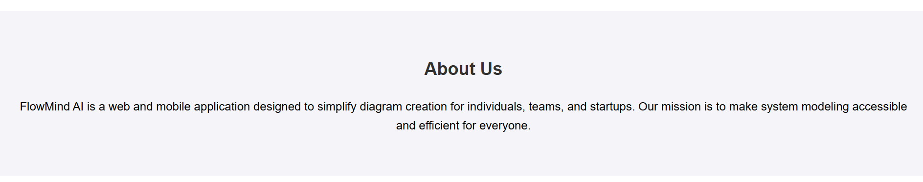
Screen 3.2: About Us

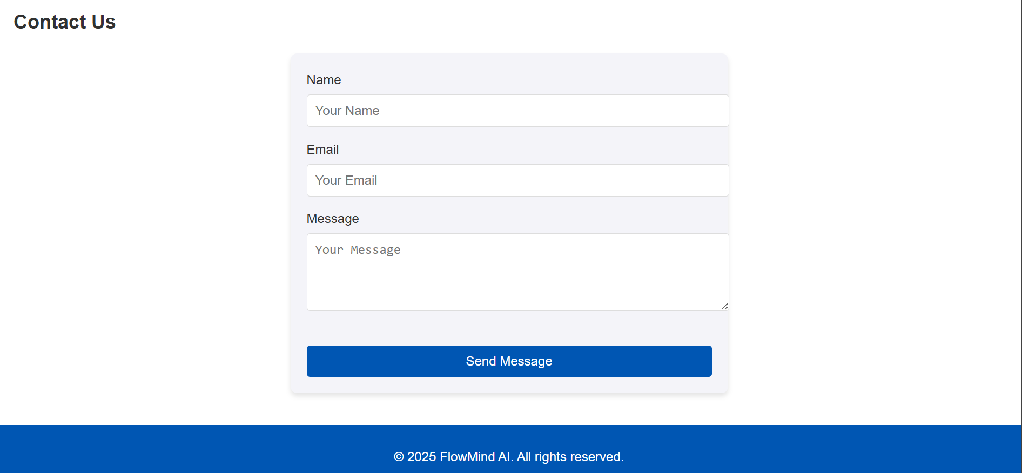
Screen 3.3: Contact Us

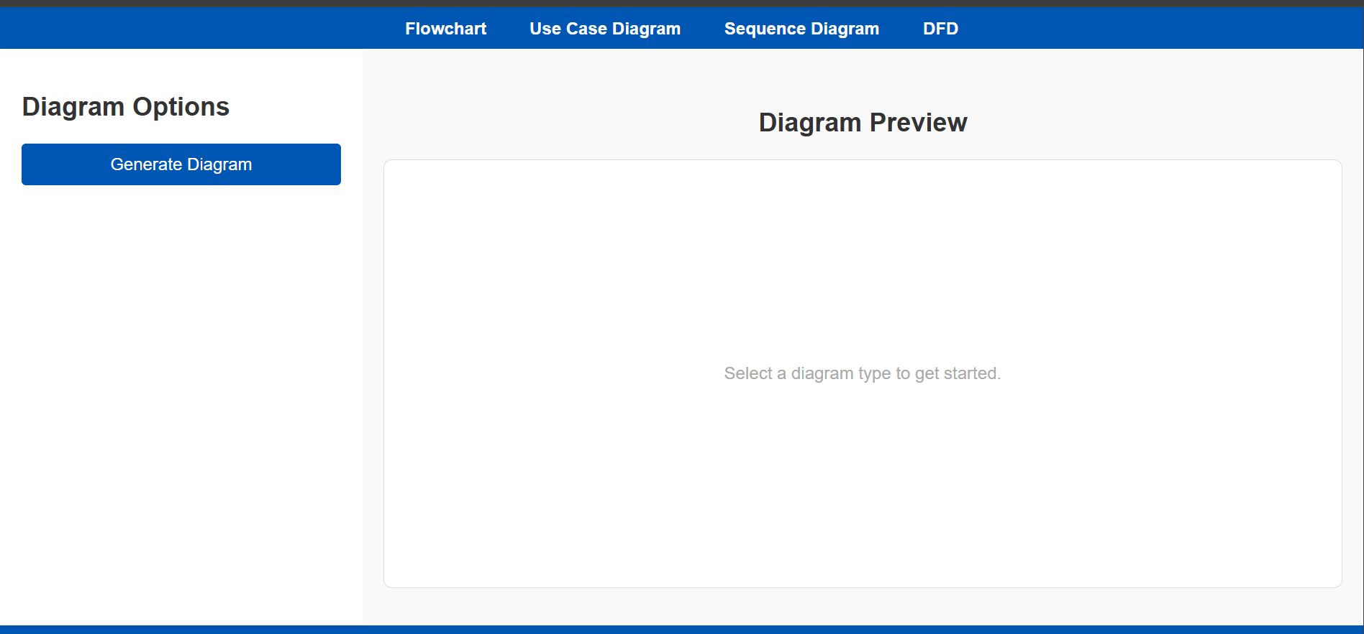
Screen 4: Diagrams Page

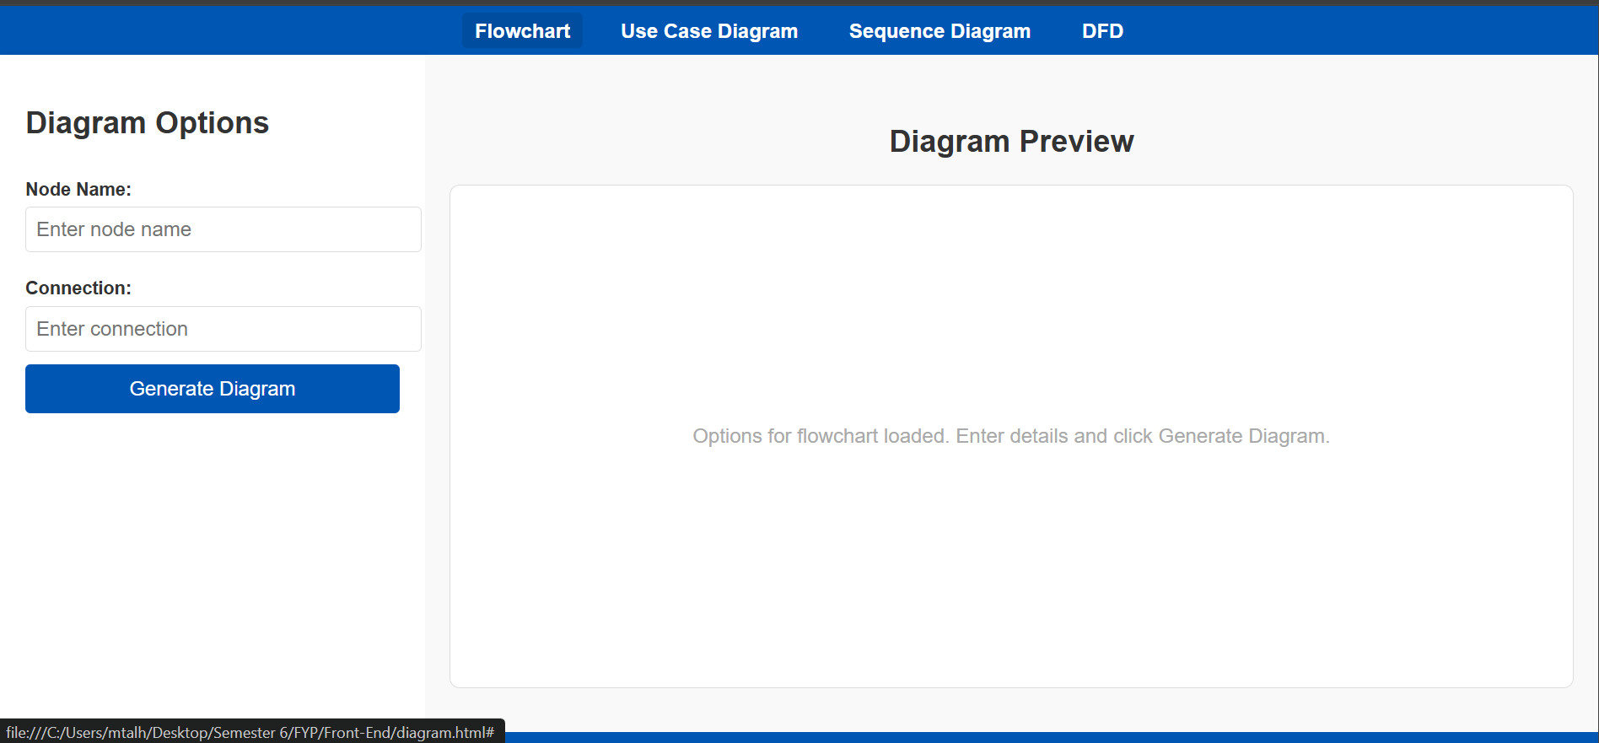
Screen 4.1: Flowchart

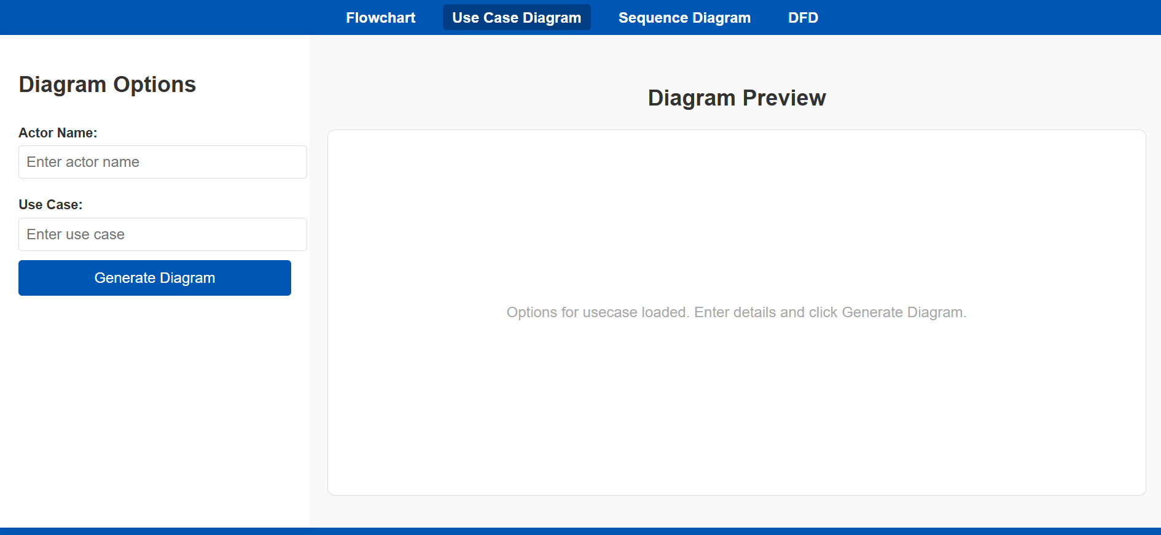
Screen 4.2: Use Case

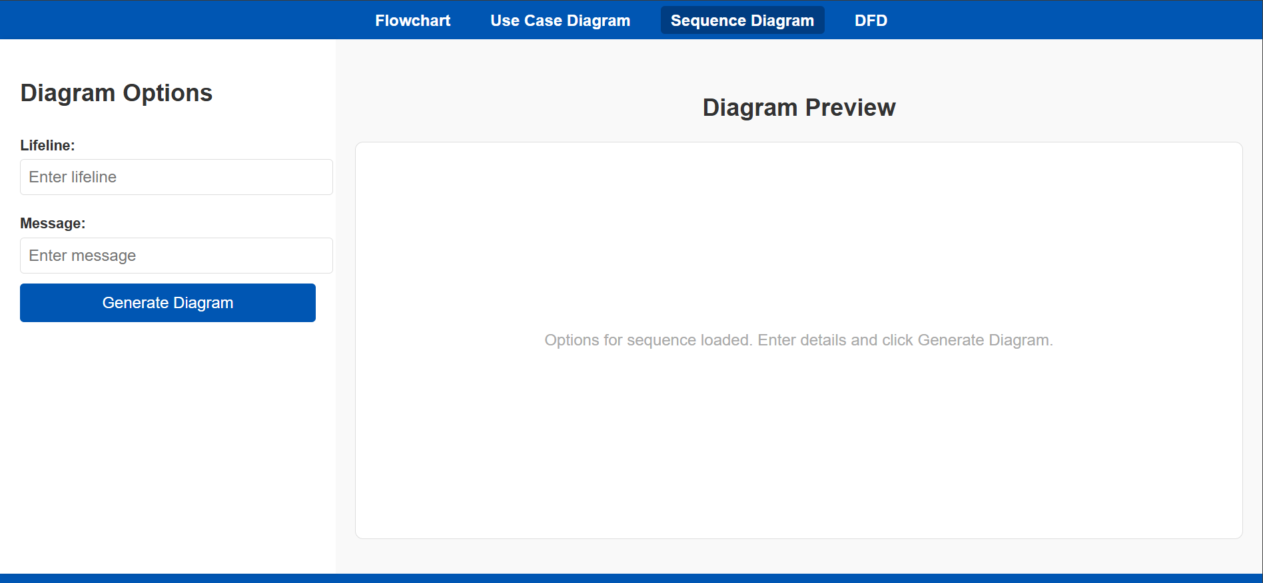
Screen 4.3: Sequence

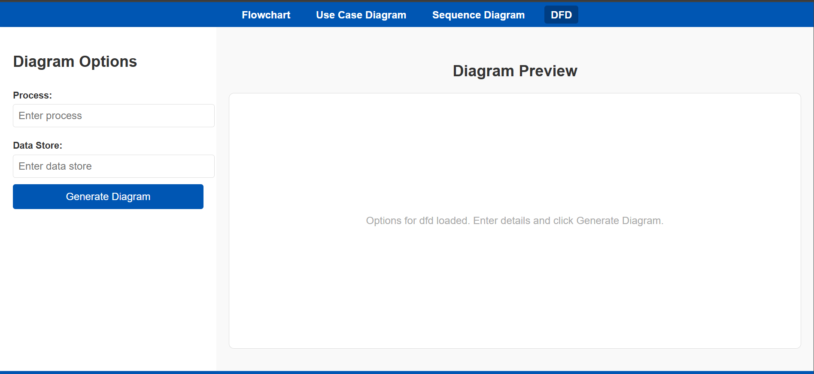
Screen 4.4: DFD

Additional Information
All critical information regarding the diagram creation workflow, functionality, and design has been detailed in the previous sections, including:
- Supported Diagrams:
  - Flowchart
  - Use Case Diagram
  - Sequence Diagram
  - Data Flow Diagram (DFD)
- Dynamic Sidebar Options:
  - Each diagram type has specific input fields (e.g., nodes, actors, processes) to guide the user in entering necessary details.
- Diagram Preview and Rendering:
  - The preview area dynamically updates based on the selected diagram type and user inputs.
  - Placeholder content or live rendering is displayed until final diagram generation.
- Customization Options:
  - Editable nodes, connections, labels, and other components specific to the diagram type.
- Export Options:
  - Generated diagrams can be saved as PNG or PDF files for further use in reports and presentations.

Other Design Details
All the necessary design details, including workflow, supported diagram types, dynamic sidebar functionality, diagram rendering and preview, and export options, have been thoroughly covered in the previous sections. No additional design details are required at this point. Any further enhancements or changes will be addressed based on testing or user feedback.

Revised Project Plan

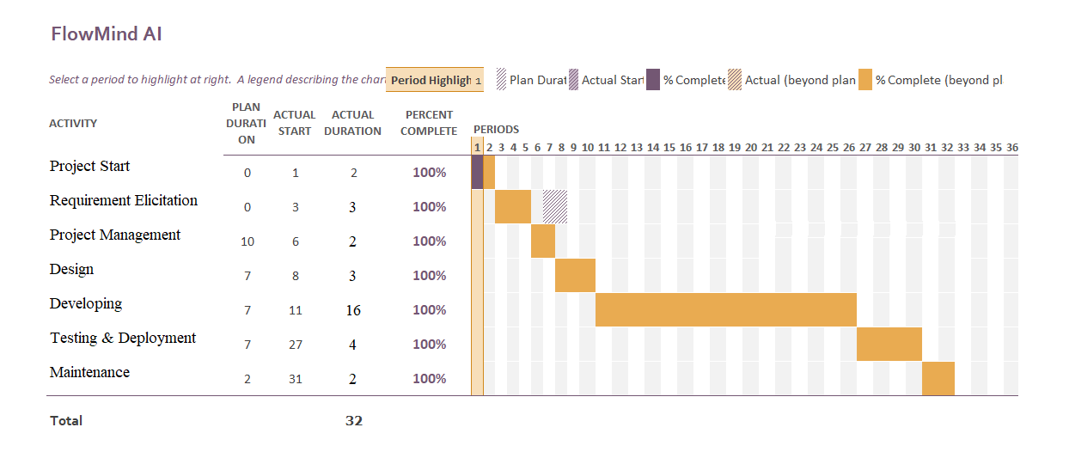
References
- Narawita, C. R. (2017). UML generator-use case and class diagram generation from text requirements. The International Journal on Advances in ICT for Emerging Regions, 10(1).
- Mukhtar, M. I., & Galadanci, B. S. (2018). Automatic code generation from UML diagrams: the state-of-the-art. Science World Journal, 13(4), 47-60.
- Tiwari, R. G., Srivastava, A. P., Bhardwaj, G., & Kumar, V. (2021, April). Exploiting UML diagrams for test case generation: a review. In 2021 2nd international conference on intelligent engineering and management (ICIEM) (pp. 457-460). IEEE.
- Segundo, L. M., Herrera, R. R., & Herrera, K. Y. P. (2007, September). UML sequence diagram generator system from use case description using natural language. In Electronics, Robotics and Automotive Mechanics Conference (CERMA 2007) (pp. 360-363). IEEE.
- Gulia, S., & Choudhury, T. (2016, January). An efficient automated design to generate UML diagram from Natural Language Specifications. In 2016 6th international conference-cloud system and big data engineering (Confluence) (pp. 641-648). IEEE.
- Narawita, C. R., & Vidanage, K. (2016, September). UML generator-an automated system for model driven development. In 2016 Sixteenth International Conference on Advances in ICT for Emerging Regions (ICTer) (pp. 250-256). IEEE.
- Usman, M., & Nadeem, A. (2009). Automatic generation of Java code from UML diagrams using UJECTOR. International Journal of Software Engineering and Its Applications, 3(2), 21-37.
- Sunitha, E. V., & Samuel, P. (2019). Automatic code generation from UML state chart diagrams. IEEE Access, 7, 8591-8608.
- Bhullar, N. S., Chhabra, B., & Verma, A. (2016, August). Exploration of UML diagrams based code generation methods. In 2016 International Conference on Inventive Computation Technologies (ICICT) (Vol. 2, pp. 1-6). IEEE.
- Doungsa-ard, C., Dahal, K. P., Hossain, M. A., & Suwannasart, T. (2007). An automatic test data generation from UML state diagram using genetic algorithm.
Appendix A: Glossary
<Define all the terms necessary to properly interpret the SRS, including acronyms and abbreviations. You may wish to build a separate glossary that spans multiple projects or the entire organization, and just include Appendix B: IV & V Report

(Independent verification & validation)
IV & V Resource

Name Signature

S# | Defect Description | Origin Stage | Status | Fix Time
 |  |  |  | Hours | Minutes
1
2
3
…
Table 1: List of non-trivial defects

This document has been adapted from the following:
- Previous project templates at UCP
- High-level Technical Design, Centers for Medicare & Medicaid Services. (www.cms.gov)
terms specific to a single project in each SRS.>

